Our Saviour’s Lutheran Church
Seaside, Oregon

Our Mission: To receive and share the grace of Christ

Fifth Sunday of Easter
April 28, 2024

Today is the Fifth Sunday of Easter

This Sunday’s image of how the risen Christ shares his life with us is the image of the vine. Christ the vine and we the branches are alive in each other, in the mystery of mutual abiding described in the gospel and the first letter of John. Baptism makes us a part of Christ’s living and life-giving self and makes us alive with Christ’s life. As the vine brings food to the branches, Christ feeds us at his table. We are sent out to bear fruit for the life of the world.

A special note for our visitors:

We’re glad you’re here! All are welcome to join us at the altar for Holy Communion. Please fill out a blue visitor card from the pew racks or sign our guest register. Please join us for coffee and snacks following worship.

To the parents of young children:

The presence of children is a blessing for the church. We welcome them as we welcome you. We expect them to be wiggly and giggly, happy and cranky.
See a greeter for a worship activity bag.

Welcome to Our Saviour’s Lutheran Church

We are a member congregation of the Oregon Synod
of the Evangelical Lutheran Church in America.
The Reverend Sue Irvin, Pastor
phone: 361-243-0981 email: pastor.oslcseaside@gmail.com
Website: oslc-seaside.org
Lori McDonald, Parish Administrative Assistant
Church Office: 503-738-6791 email: oslc.seaside97138@gmail.com
Prelude

Welcome

The Lord be with you. And also with you.

Confession and Forgiveness

Blessed be the holy Trinity, ☩ one God, who forgives all our sin, whose mercy endures forever. Amen.

God of all mercy and consolation, come to the help of your people, turning us from our sin to live for you alone. Give us the power of your Holy Spirit that we may confess our sin, receive your forgiveness, and grow into the fullness of Jesus Christ, our Savior and Lord. Amen.

Let us confess our sin in the presence of God and of one another, taking a moment of silence for contemplation.

Gracious God, have mercy on us. We confess that we have turned from you and given ourselves into the power of sin. We are truly sorry and humbly repent. In your compassion forgive us our sins, known and unknown, things we have done and things we have failed to do. Turn us again to you, and uphold us by your Spirit, so that we may live and serve you in newness of life through Jesus Christ, our Savior and Lord. Amen.

God, who is rich in mercy, loved us even when we were dead in sin, and made us alive together with Christ. By grace you have been saved. In the name of ☩ Jesus Christ, your sins are forgiven. Almighty God strengthen you with power through the Holy Spirit, that Christ may live in your hearts through faith. Amen.

Gathering Hymn: “Jesus Loves Me”
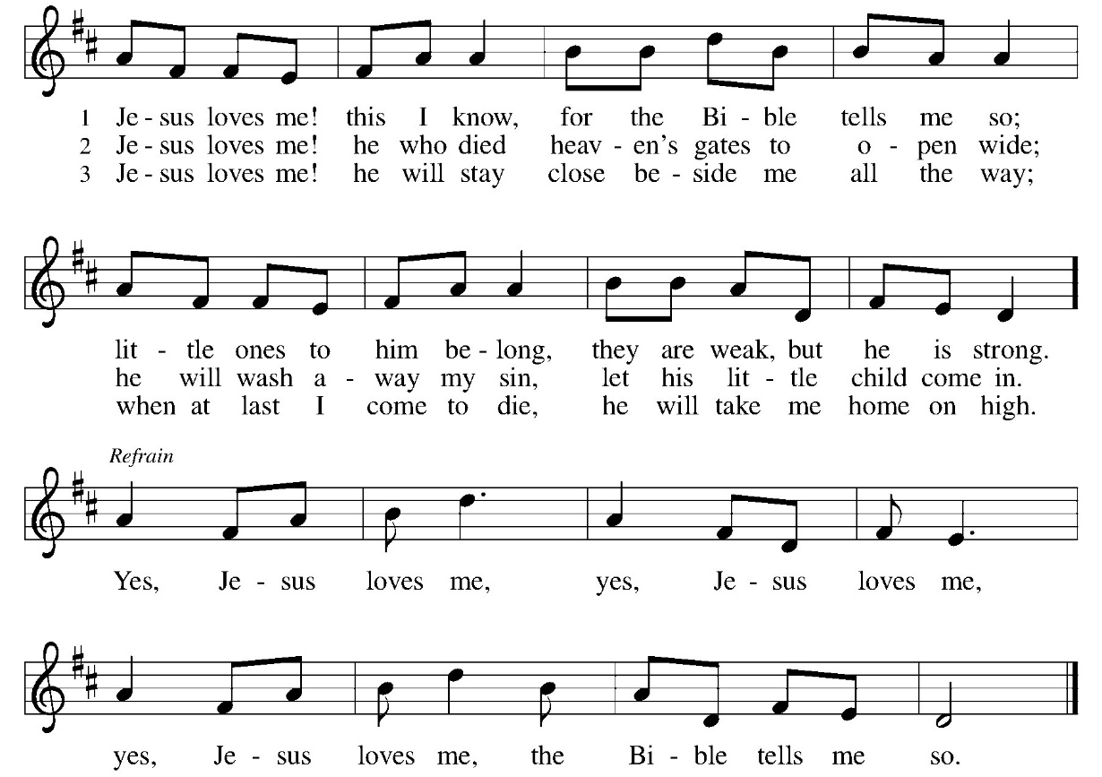
Greeting

The grace of our Lord Jesus Christ, the love of God, and the communion of the Holy Spirit be with you all. And also with you.
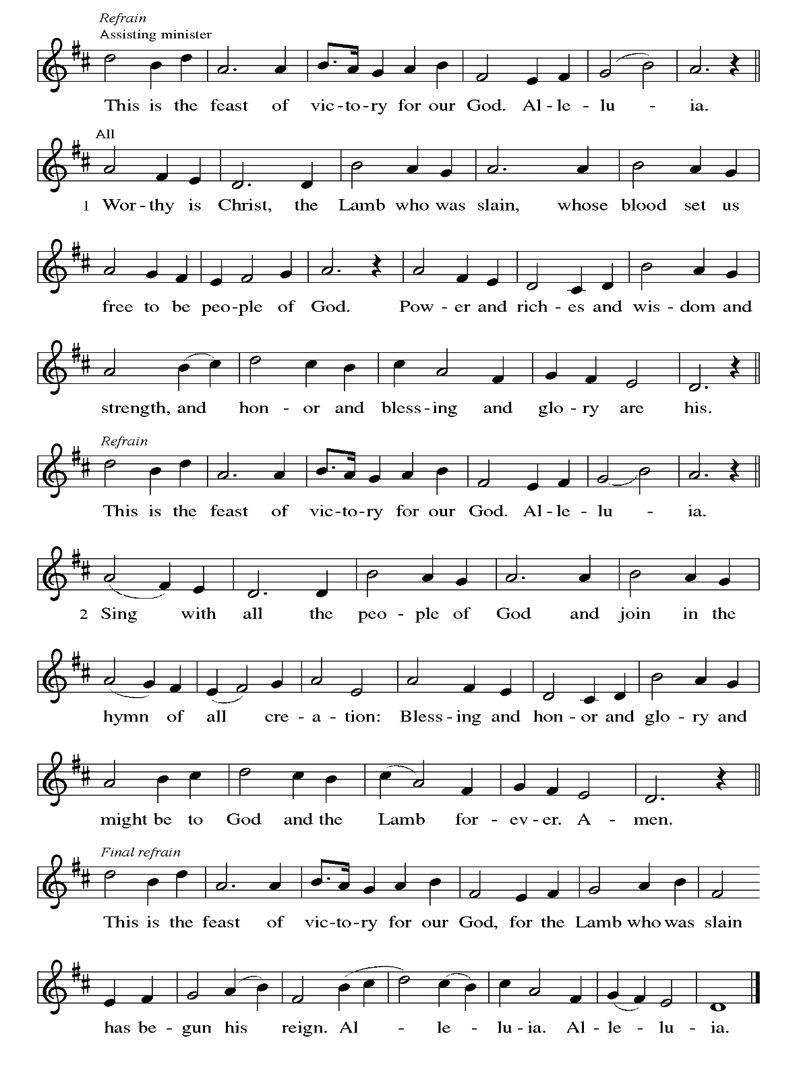
Hymn of Praise
Prayer of the Day

Let us pray: O God, you give us your Son as the vine apart from whom we cannot live. Nourish our life in his resurrection, that we may bear the fruit of love and know the fullness of your joy, through Jesus Christ, our Savior and Lord, who lives and reigns with you and the Holy Spirit, one God, now and forever. Amen.

First Reading: Acts 8:26-40

²⁶An angel of the Lord said to Philip, “Get up and go toward the south to the road that goes down from Jerusalem to Gaza.” (This is a wilderness road.) ²⁷So he got up and went. Now there was an Ethiopian eunuch, a court official of the Candace, queen of the Ethiopians, in charge of her entire treasury. He had come to Jerusalem to worship ²⁸and was returning home; seated in his chariot, he was reading the prophet Isaiah. ²⁹Then the Spirit said to Philip, “Go over to this chariot and join it.” ³⁰So Philip ran up to it and heard him reading the prophet Isaiah. He asked, “Do you understand what you are reading?” ³¹He replied, “How can I, unless someone guides me?” And he invited Philip to get in and sit beside him. ³²Now the passage of the scripture that he was reading was this:
“Like a sheep he was led to the slaughter,
and like a lamb silent before its shearer,
so he does not open his mouth.
³³In his humiliation justice was denied him.
Who can describe his generation?
For his life is taken away from the earth.”
³⁴The eunuch asked Philip, “About whom, may I ask you, does the prophet say this, about himself or about someone else?” ³⁵Then Philip began to speak, and starting with this scripture, he proclaimed to him the good news about Jesus. ³⁶As they were going along the road, they came to some water; and the eunuch said, “Look, here is water! What is to prevent me from being baptized?” ³⁸He commanded the chariot to stop, and both of them, Philip and the eunuch, went down into the water, and Philip baptized him. ³⁹When they came up out of the water, the Spirit of the Lord snatched Philip away; the eunuch saw him no more, and went on his way rejoicing. ⁴⁰But Philip found himself at Azotus, and as he was passing through the region, he proclaimed the good news to all the towns until he came to Caesarea.

Word of God. Word of life. Thanks be to God.

Psalm: Psalm 22:25-31

²⁵From you comes my praise in the great assembly;
I will perform my vows in the sight of those who fear the Lord.
²⁶The poor shall eat and be satisfied,
Let those who seek the Lord give praise!
May your hearts live forever!
²⁷All the ends of the earth shall remember and turn to the Lord;
all the families of nations shall bow before God.
²⁸For dominion belongs to the Lord,
who rules over the nations.
²⁹Indeed, all who sleep in the earth shall bow down in worship;
all who go down to the dust, though they be dead,
shall kneel before the Lord.
³⁰Their descendants shall serve the Lord,
whom they shall proclaim to generations to come.
³¹They shall proclaim God’s deliverance to a people yet unborn,
saying to them, “The Lord has acted!”

Second Reading: 1 John 4:7-21

⁷Beloved, let us love one another, because love is from God; everyone who loves is born of God and knows God. ⁸Whoever does not love does not know God, for God is love. ⁹God’s love was revealed among us in this way: God sent his only Son into the world so that we might live through him. ¹⁰In this is love, not that we loved God but that he loved us and sent his Son to be the atoning sacrifice for our sins. ¹¹Beloved, since God loved us so much, we also ought to love one another. ¹²No one has ever seen God; if we love one another, God lives in us, and his love is perfected in us.
¹³By this we know that we abide in him and he in us, because he has given us of his Spirit. ¹⁴And we have seen and do testify that the Father has sent his Son as the Savior of the world. ¹⁵God abides in those who confess that Jesus is the Son of God, and they abide in God. ¹⁶So we have known and believe the love that God has for us.
God is love, and those who abide in love abide in God, and God abides in them. ¹⁷Love has been perfected among us in this: that we may have boldness on the day of judgment, because as he is, so are we in this world. ¹⁸There is no fear in love, but perfect love casts out fear; for fear has to do with punishment, and whoever fears has not reached perfection in love. ¹⁹We love because he first loved us. ²⁰Those who say, “I love God,” and hate their brothers or sisters, are liars; for those who do not love a brother or sister whom they have seen, cannot love God whom they have not seen. ²¹The commandment we have from him is this: those who love God must love their brothers and sisters also.

Word of God. Word of life. Thanks be to God.

Gospel Acclamation (stand as able)
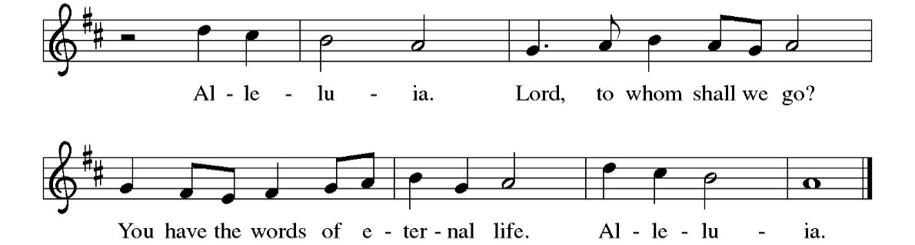
Gospel: John 15:1-8

The Holy Gospel according to St. John. Glory to you, O Lord.

[Jesus said:] ¹“I am the true vine, and my Father is the vinegrower. ²He removes every branch in me that bears no fruit. Every branch that bears fruit he prunes to make it bear more fruit. ³You have already been cleansed by the word that I have spoken to you. ⁴Abide in me as I abide in you. Just as the branch cannot bear fruit by itself unless it abides in the vine, neither can you unless you abide in me. ⁵I am the vine, you are the branches. Those who abide in me and I in them bear much fruit, because apart from me you can do nothing. ⁶Whoever does not abide in me is thrown away like a branch and withers; such branches are gathered, thrown into the fire, and burned. ⁷If you abide in me, and my words abide in you, ask for whatever you wish, and it will be done for you. ⁸My Father is glorified by this, that you bear much fruit and become my disciples.”

The Gospel of our Lord. Praise to you, O Christ.

Sermon
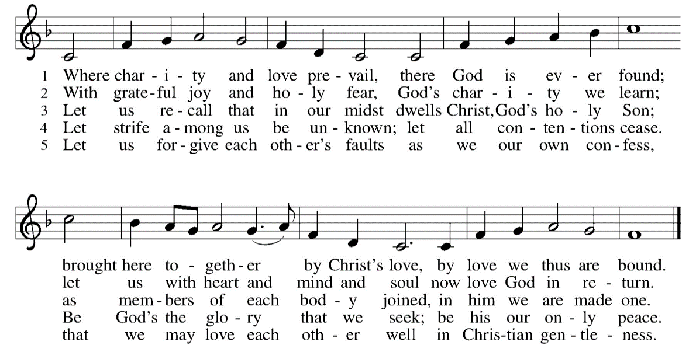
Hymn of the Day: “Where Charity and Love Prevail” (stand as able)

Profession of Faith: The Nicene Creed

We believe in one God, the Father, the Almighty, maker of heaven and earth, of all that is, seen and unseen.

We believe in one Lord, Jesus Christ, the only Son of God, eternally begotten of the Father, God from God, Light from Light, true God from true God, begotten, not made, of one Being with the Father; through him all things were made. For us and for our salvation he came down from heaven, was incarnate of the Holy Spirit and the virgin Mary and became truly human. For our sake he was crucified under Pontius Pilate; he suffered death and was buried. On the third day he rose again in accordance with the scriptures; he ascended into heaven and is seated at the right hand of the Father. He will come again in glory to judge the living and the dead, and his kingdom will have no end.

We believe in the Holy Spirit, the Lord, the giver of life, who proceeds from the Father and the Son, who with the Father and the Son is worshiped and glorified, who has spoken through the prophets. We believe in one holy catholic and apostolic church. We acknowledge one baptism for the forgiveness of sins. We look for the resurrection of the dead, and the life of the world to come. Amen.

Prayers of Intercession (sit or kneel)

P: Rejoicing that Jesus is risen, and love has triumphed over fear, let us pray for the church, the world, and all those in need of good news.

A: We pray for the church around the world, for all ministers, and for the mission of the gospel. Fill your church with love and equip us to serve with abundant grace.

A: We pray for the well-being of the earth and of all created things. Renew the face of the earth and shower us with your goodness.

A: We pray for the nations and all those in authority. Let your great love shine through the hearts of leaders, and lead us from hate to love, from war to peace.

A: We pray for all those in need: for all who are ill or suffering, for all who are lonely, for all who feel unloved. We pray especially for the family of
W.C. Peinhardt, Jim Haugen, Ruth Karo, Sara Wirkkala, Steve Larkins, Danielle Thompson-Campbell, Dona Fanning, and all those we lift up to you now, aloud or in our hearts… Lord, in your mercy, hear our prayer.

A: We pray for this congregation. Bless the caring ministries of this faith community. Guide as we minister to one another and as we seek to share your love with the world.

A: We give thanks for the saints who rest from their labors. May their memories be a blessing for us and their lives an example of faithfulness for us.

P: Into your hands, most merciful God, we commend all for whom we pray, trusting in your abiding love; through Jesus Christ, our resurrected and living Lord. Amen.

The peace of Christ be with you always. And also with you.

You are invited to share a sign of Christ’s peace, as you are
comfortable, and may say Peace be with you or similar words.

After sharing Christ’s peace, the assembly is seated.

Offering
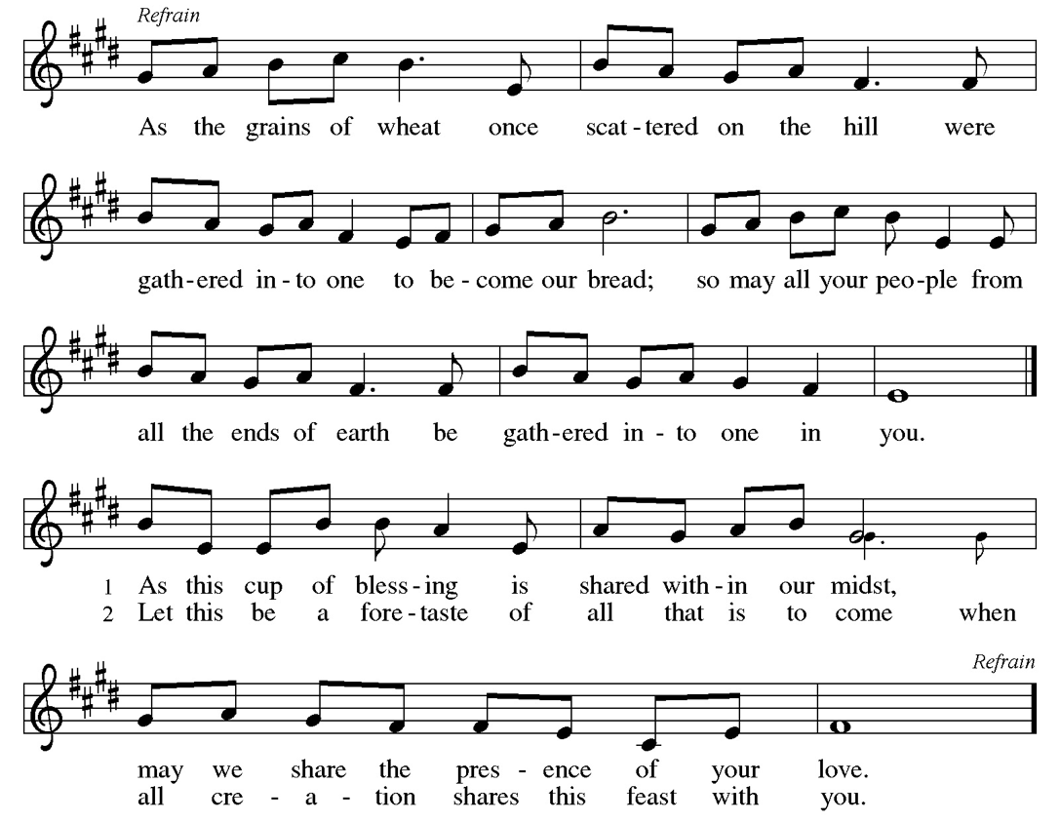
Offertory (stand as able)

Offering Prayer

Let us pray: Risen One, you call us to believe and bear fruit. May the gifts that we offer here be signs of your love. Form us to be your witnesses in the world, through Jesus Christ, our true vine. Amen.

Thanksgiving at the Table

The Lord be with you. And also with you.
Lift up your hearts. We lift them to the Lord.
Let us give thanks to the Lord our God. It is right to give our thanks and praise.
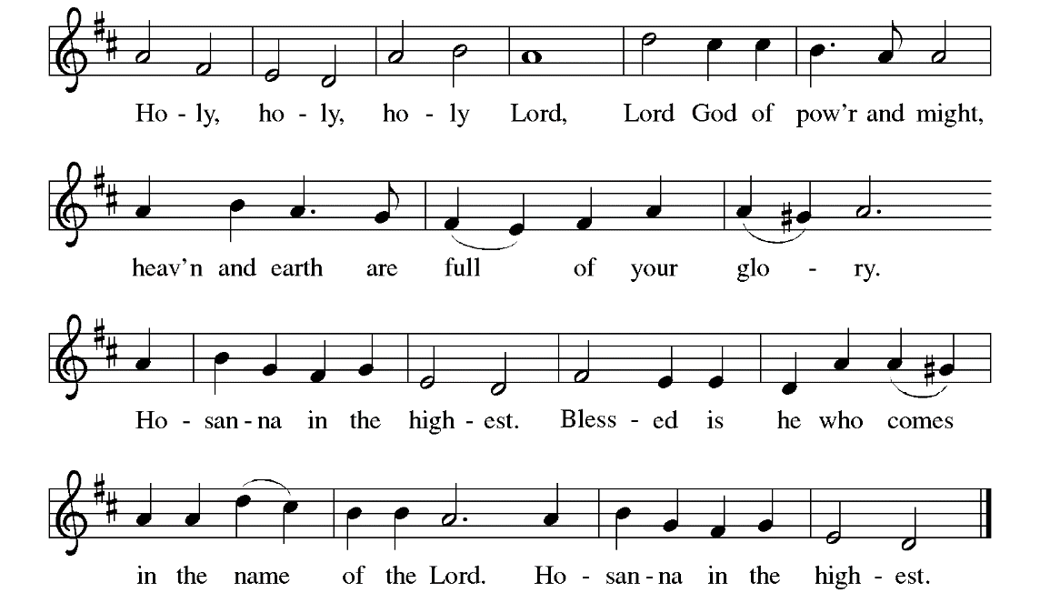
It is indeed right, our duty and our joy, that we should at all times and in all places give thanks and praise to you, almighty and merciful God, for the glorious resurrection of ourSavior Jesus Christ, the true Paschal Lamb who gave himself to take away our sin; who in dying has destroyed death, and in rising has brought us to eternal life. And so, with Mary Magdalene and Peter and all the witnesses of the resurrection, with angels and archangels, cherubim and seraphim, we praise your name and join their unending hymn:

Holy, mighty, and merciful Lord, heaven and earth are full of your glory. In great love you sent to us Jesus, your Son, who reached out to heal the sick and suffering, who preached good news to the poor, and who, on the cross, opened his arms to all.

On the night before he died, our Lord Jesus took bread, and gave thanks; broke it, and gave it to his disciples, saying: Take and eat; this is my body, given for you. Do this in remembrance of me.
After supper, he took the cup, gave thanks, and gave it for all to drink, saying: This cup is the new covenant in my blood, shed for you and for all people for the forgiveness of sin. Do this in remembrance of me.

Remembering, therefore, his death, resurrection, and ascension, we await his coming in glory. Together, we proclaim the mystery of our faith:
Christ has died. Christ is risen. Christ will come again.

Pour out upon us the Spirit of your love, O Lord, and unite the wills of all who share this heavenly food, the body and blood of Jesus Christ, our Lord; to whom, with you and the Holy Spirit, be all honor and glory, now and forever. Amen.

The Lord’s Prayer use the version you prefer

Wherever we are, we are gathered into one by the Holy Spirit and can boldly pray as our Lord has taught us:

Our Father in heaven, Our Father, who art in heaven,
hallowed be your name, hallowed be thy name, thy
your kingdom come, your kingdom come, thy will be
will be done, on earth as done, on earth as it is in
in heaven. Give us today our heaven. Give us this day our
daily bread. Forgive us our daily bread; and forgive us our
sins as we forgive those who trespasses, as we forgive those
those who sin against us. who trespass against us; and
Save us from the time of trial, lead us not into temptation, but
and deliver us from evil. For deliver us from evil. For thine
the kingdom, the power, and is the kingdom, and the power,
the glory are yours, now and and the glory, forever and
forever. Amen. ever. Amen.

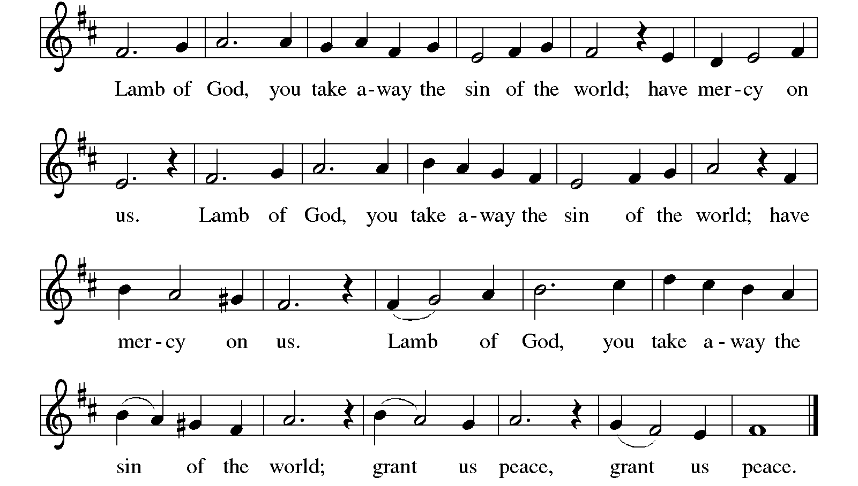
These are the gifts of God for the children of God. All who believe, all who want to believe, are welcome at the table of our Lord’s grace and mercy. Jesus is the host; we are the guests. Thanks be to God.

Come to the table, for all is prepared, and there is a place for you.

Those at home are invited to take their bread and wine or juice at this time.

Communion is distributed by intinction, dipping the bread into wine or juice.
If you prefer grape juice, cross your arms after receiving the bread and the assisting minister will pass by, and the acolyte will offer a chalice of grape juice. Please notify the server if you prefer a gluten free wafer.

May the body and blood of our Lord Jesus Christ strengthen and preserve you now and always. Amen.

Prayer after Communion

Let us pray: Shepherding God, you have prepared a table before us and nourished us with your love. Send us forth from this banquet to proclaim your goodness and share the abundant mercy of Jesus, our redeemer and friend. Amen.

Announcements A complete list of announcements can be found
at the end of the bulletin.

Blessing

The God of steadfastness and encouragement grant you to live in harmony with one another, in accordance with Christ Jesus. The God of hope fill you with all joy and peace in believing, so that you may abound in hope by the power of the Holy Spirit. The God of all grace ☩ bless you now and forever. Amen.

Liturgy: SundaysandSeasons.com, copyright 2024, Augsburg Fortress. All rights reserved. Reprinted by permission under Augsburg Fortress, Annual License SAS011383. Hymns: Reprinted by permission under One License Annual License #A-728769. Scripture texts New Revised Standard Version Bible, copyright © 1989 the Division of Christian Education of the National Council of the Churches of Christ in the United States of America. Used by permission. All rights reserved.
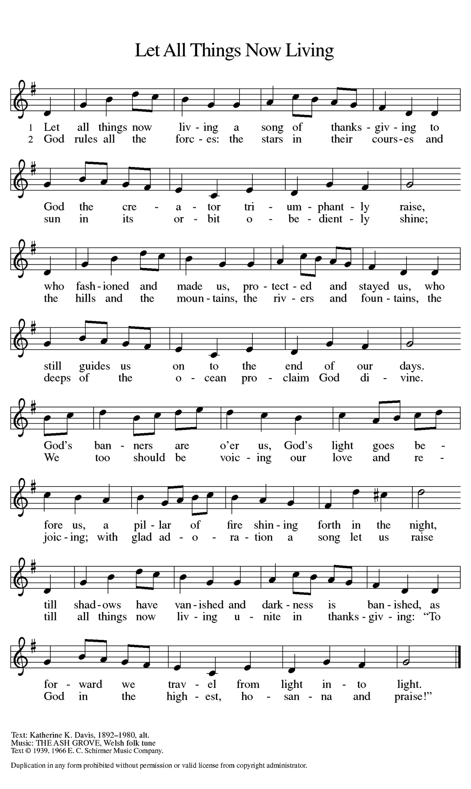
Sending Hymn: “Let All Things Now Living”

Dismissal

Let us go in peace to love and serve the Lord. Thanks be to God! Alleluia!

Serving Today

Presiding Minister: Pastor Sue Irvin
Assisting Minister: Doug Sugano
Music Director/Accompanist: Beth Adee
Guitarists: Josh Moorman
Robert Ydstie
Sacristan: Jim Haugen
Acolyte: David Nelson
Communion Prep: Michael Barnet
Ushers: Julia Fanning &
Claudia Halliburton
Offering Counters: Tami Olson &
Debbie Walter

Flowers given today by Cathy & Al Peinhardt

Coming Up at Our Saviour’s

Tuesday at 10:30 am Ecumenical Bible Study, East Hall
Thursday at 9:30 am Quilters, East Hall
Sunday, May 5 Sixth Sunday of Easter
9:00 am Bible Study
10:00 am Worship
11:00 am Fellowship, East Hall

Announcements

This week only: Please send announcements and updates to the prayer request list to the church office, by phone or email, by 10 am on Tuesday, or fill out an announcement form (located in the Council Corner in the East Hall) and place in the basket on Pastor Sue’s door.

A signup sheet for people interested in participating in our bell choir can be found on the whiteboard in the East Hall.

Collection list for the South County Food Bank: canned fruit, pork & beans, soup, mayonnaise, mustard, ketchup, syrup, pancake mix. The collection barrel is by the mailboxes in the front entry.

