Our Saviour’s Lutheran Church
Seaside, Oregon

Our Mission: To receive and share the grace of Christ

Fourth Sunday of Easter
April 21, 2024
Today is the Fourth Sunday of Easter

The image of the good shepherd shows us how the risen Christ brings us to life. It is the relationship between the shepherd and the sheep, one of mutual knowledge and love, that gives the shepherd authority. The shepherd’s willingness to lay down his life for the sheep shows his love. First John illustrates what it means to lay down our lives for one another by the example of sharing our wealth with any sibling in need.

A special note for our visitors:

We’re glad you’re here! All are welcome to join us at the altar for Holy Communion. Please fill out a blue visitor card from the pew racks or sign our guest register. Please join us for coffee and snacks following worship.

To the parents of young children:

The presence of children is a blessing for the church. We welcome them as we welcome you. We expect them to be wiggly and giggly, happy and cranky.
See a greeter for a worship activity bag.

Welcome to Our Saviour’s Lutheran Church

We are a member congregation of the Oregon Synod
of the Evangelical Lutheran Church in America.
The Reverend Sue Irvin, Pastor
phone: 361-243-0981 email: pastor.oslcseaside@gmail.com
Website: oslc-seaside.org
Lori McDonald, Parish Administrative Assistant
Church Office: 503-738-6791 email: oslc.seaside97138@gmail.com
Prelude

Welcome

The Lord be with you. And also with you.

Confession and Forgiveness (sit or kneel)

Blessed be the holy Trinity, ☩ one God, who forgives all our sin, whose mercy endures forever. Amen.

God of all mercy and consolation, come to the help of your people, turning us from our sin to live for you alone. Give us the power of your Holy Spirit that we may confess our sin, receive your forgiveness, and grow into the fullness of Jesus Christ, our Savior and Lord. Amen.

Let us confess our sin in the presence of God and of one another, taking a moment of silence for contemplation.

Gracious God, have mercy on us. We confess that we have turned from you and given ourselves into the power of sin. We are truly sorry and humbly repent. In your compassion forgive us our sins, known and unknown, things we have done and things we have failed to do. Turn us again to you, and uphold us by your Spirit, so that we may live and serve you in newness of life through Jesus Christ, our Savior and Lord. Amen.

God, who is rich in mercy, loved us even when we were dead in sin, and made us alive together with Christ. By grace you have been saved. In the name of ☩ Jesus Christ, your sins are forgiven. Almighty God strengthen you with power through the Holy Spirit, that Christ may live in your hearts through faith. Amen.

Gathering Hymn: “Good Christian Friends Rejoice and Sing”
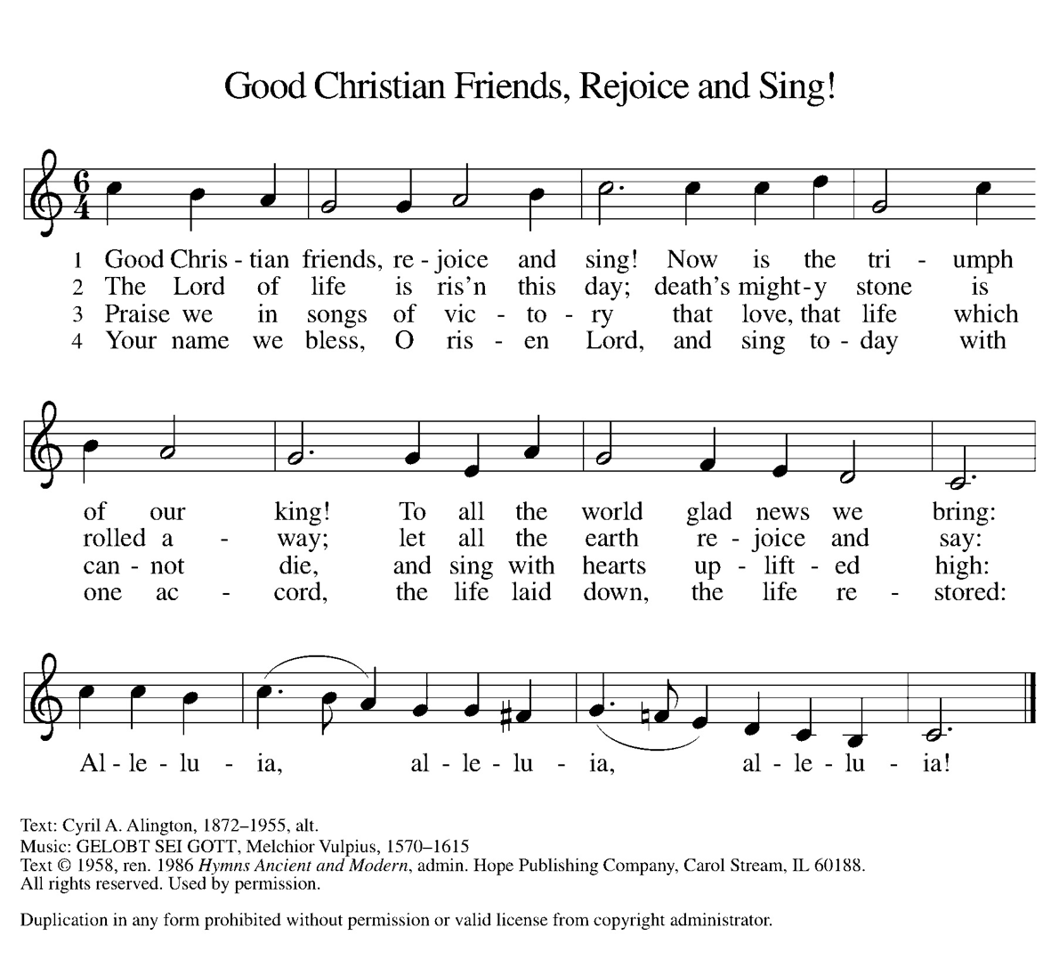
(stand as able)

Greeting

The grace of our Lord Jesus Christ, the love of God, and the communion of the Holy Spirit be with you all. And also with you.

Liturgy: SundaysandSeasons.com, copyright 2024, Augsburg Fortress. All rights reserved. Reprinted by permission under Augsburg Fortress, Annual License SAS011383. Hymns: Reprinted by permission under One License Annual License #A-728769. Scripture texts New Revised Standard Version Bible, copyright © 1989 the Division of Christian Education of the National Council of the Churches of Christ in the United States of America. Used by permission. All rights reserved.
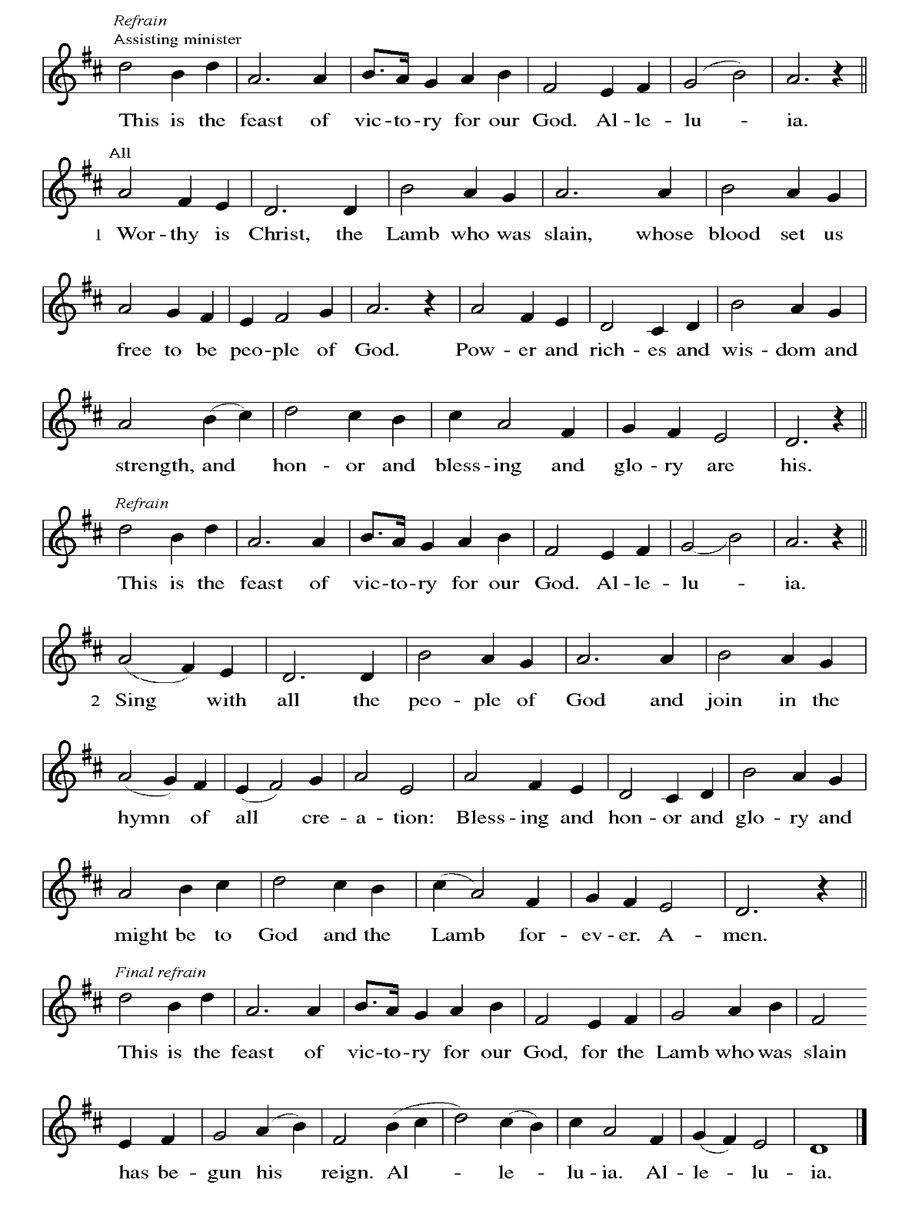
Hymn of Praise

Prayer of the Day

Let us pray: O Lord Christ, good shepherd of the sheep, you seek the lost and guide us into your fold. Feed us, and we shall be satisfied; heal us, and we shall be whole. Make us one with you, for you live and reign with the Father and the Holy Spirit, one God, now and forever.
Amen.

First Reading: Acts 4:5-12

⁵The next day [the] rulers, elders, and scribes assembled in Jerusalem, ⁶with Annas the high priest, Caiaphas, John, and Alexander, and all who were of the high-priestly family. ⁷When they had made the prisoners stand in their midst, they inquired, “By what power or by what name did you do this?” ⁸Then Peter, filled with the Holy Spirit, said to them, “Rulers of the people and elders, ⁹if we are questioned today because of a good deed done to someone who was sick and are asked how this man has been healed, ¹⁰let it be known to all of you, and to all the people of Israel, that this man is standing before you in good health by the name of Jesus Christ of Nazareth, whom you crucified, whom God raised from the dead. ¹¹This Jesus is
‘the stone that was rejected by you, the builders;
it has become the cornerstone.’
¹²There is salvation in no one else, for there is no other name under heaven given among mortals by which we must be saved.”

Word of God. Word of life. Thanks be to God.

Psalm: Psalm 23

¹The Lord is my shepherd;
I shall not be in want.
²The Lord makes me lie down in green pastures
and leads me beside still waters.
³You restore my soul, O Lord,
and guide me along right pathways for your name’s sake.
⁴Though I walk through the valley of the shadow of death,
I shall fear no evil; for you are with me;
your rod and your staff, they comfort me.
⁵You prepare a table before me in the presence of my enemies;
you anoint my head with oil, and my cup is running over.
⁶Surely goodness and mercy shall follow me all the days of my life,
and I will dwell in the house of the Lord forever.

Second Reading: 1 John 3:16-24

¹⁶We know love by this, that [Jesus Christ] laid down his life for us—and we ought to lay down our lives for one another. ¹⁷How does God’s love abide in anyone who has the world’s goods and sees a brother or sister in need and yet refuses help?
¹⁸Little children, let us love, not in word or speech, but in truth and action. ¹⁹And by this we will know that we are from the truth and will reassure our hearts before him ²⁰whenever our hearts condemn us; for God is greater than our hearts, and he knows everything. ²¹Beloved, if our hearts do not condemn us, we have boldness before God; ²²and we receive from him whatever we ask, because we obey his commandments and do what pleases him.
²³And this is his commandment, that we should believe in the name of his Son Jesus Christ and love one another, just as he has commanded us. ²⁴All who obey his commandments abide in him, and he abides in them. And by this we know that he abides in us, by the Spirit that he has given us.

Word of God. Word of life. Thanks be to God.

Gospel Acclamation (stand as able)
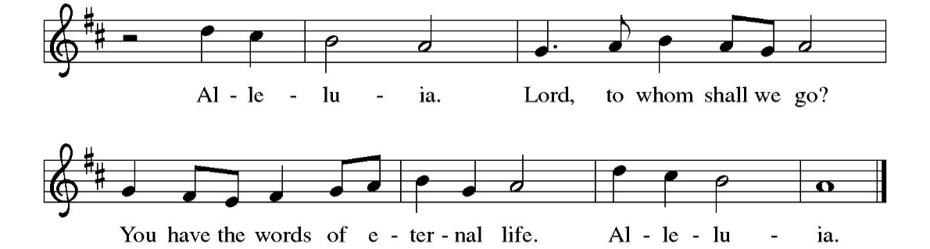
Gospel: John 10:11-18

The Holy Gospel according to St. John. Glory to you, O Lord.

[Jesus said:] ¹¹“I am the good shepherd. The good shepherd lays down his life for the sheep. ¹²The hired hand, who is not the shepherd and does not own the sheep, sees the wolf coming and leaves the sheep and runs away—and the wolf snatches them and scatters them. ¹³The hired hand runs away because a hired hand does not care for the sheep. ¹⁴I am the good shepherd. I know my own and my own know me, ¹⁵just as the Father knows me and I know the Father. And I lay down my life for the sheep. ¹⁶I have other sheep that do not belong to this fold. I must bring them also, and they will listen to my voice. So there will be one flock, one shepherd. ¹⁷For this reason the Father loves me, because I lay down my life in order to take it up again. ¹⁸No one takes it from me, but I lay it down of my own accord. I have power to lay it down, and I have power to take it up again. I have received this command from my Father.”

The Gospel of our Lord. Praise to you, O Christ.

Sermon
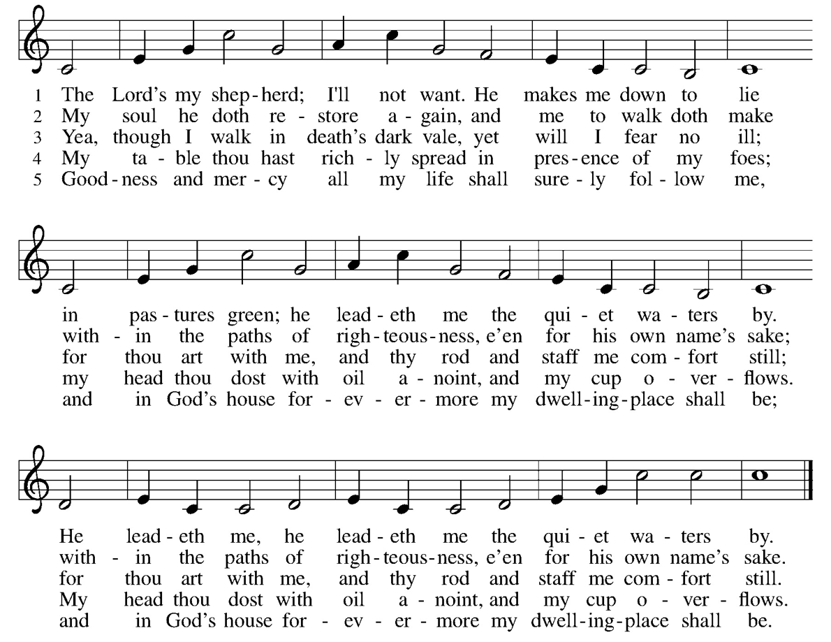
Hymn of the Day: “The Lord’s My Shepherd” (stand as able)

Blessing of Quilts and Prayer Shawls

Profession of Faith: The Nicene Creed

We believe in one God, the Father, the Almighty, maker of heaven and earth, of all that is, seen and unseen.

We believe in one Lord, Jesus Christ, the only Son of God, eternally begotten of the Father, God from God, Light from Light, true God from true God, begotten, not made, of one Being with the Father;
through him all things were made. For us and for our salvation he came down from heaven, was incarnate of the Holy Spirit and the virgin Mary and became truly human. For our sake he was crucified under Pontius Pilate; he suffered death and was buried. On the third day he rose again in accordance with the scriptures; he ascended into heaven and is seated at the right hand of the Father. He will come again in glory to judge the living and the dead, and his kingdom will have no end.

We believe in the Holy Spirit, the Lord, the giver of life, who proceeds from the Father and the Son, who with the Father and the Son is worshiped and glorified, who has spoken through the prophets. We believe in one holy catholic and apostolic church. We acknowledge one baptism for the forgiveness of sins. We look for the resurrection of the dead, and the life of the world to come. Amen.

Prayers of Intercession (sit or kneel)

P: Rejoicing that Jesus is risen, and love has triumphed over fear, let us pray for the church, the world, and all those in need of good news.

A: Shepherding God, gather your church whenever we wander from you and one another. Bless ecumenical partnerships around the world and encourage us to learn from each other as we serve those in need.

A: Creating God, you love all that you have made. Teach us to love your creation as you do, that we may be better stewards of the world around us.

A: Almighty God, you teach us to love one another as you love us. Guide leaders around the world in ways of wisdom and peace.

A: Loving God, we come to you seeking wholeness. Bless caregivers with patience. Send comfort to those who mourn. We pray especially for Jim Haugen, Ruth Karo, Sara Wirkkala, Steve Larkins, Danielle Thompson-Campbell, Dona Fanning, and all those we lift up to you now, aloud or in our hearts… Lord, in your mercy, hear our prayer.

A: Gracious God, help this and all communities of faith to listen for your voice. Call us away from things that distract us from following you. Show us new paths of service to those who are in need.

A: Living God, we give thanks for our ancestors in faith. Strengthen us to share the good news in our own day.

P: Into your hands, most merciful God, we commend all for whom we pray, trusting in your abiding love; through Jesus Christ, our resurrected and living Lord. Amen.

The peace of Christ be with you always. And also with you.

You are invited to share a sign of Christ’s peace, as you are
comfortable, and may say Peace be with you or similar words.

After sharing Christ’s peace, the assembly is seated.

Offering

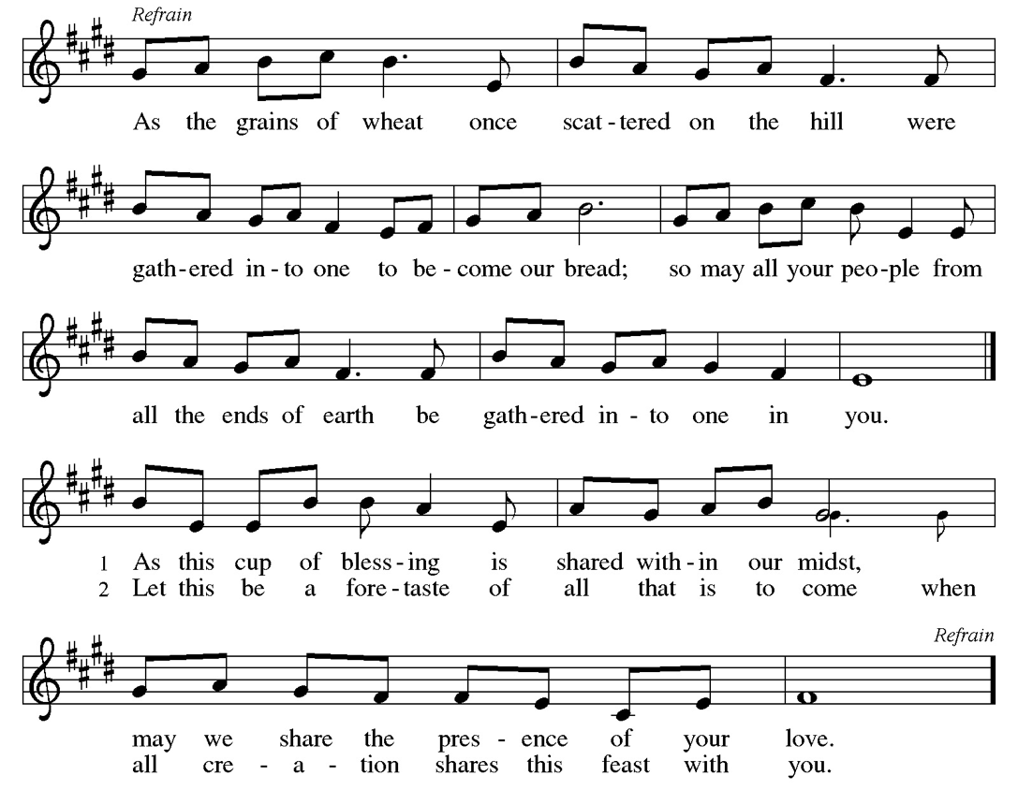
Offertory (stand as able)

Offering Prayer

Let us pray: Risen One, you call us to believe and bear fruit. May the gifts that we offer here be signs of your love. Form us to be your witnesses in the world, through Jesus Christ, our true vine. Amen.

Thanksgiving at the Table

The Lord be with you. And also with you.
Lift up your hearts. We lift them to the Lord.
Let us give thanks to the Lord our God. It is right to give our thanks and praise.
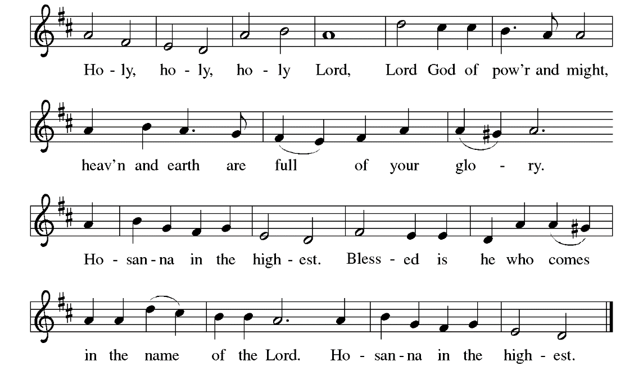
It is indeed right, our duty and our joy, that we should at all times and in all places give thanks and praise to you, almighty and merciful God, for the glorious resurrection of ourSavior Jesus Christ, the true Paschal Lamb who gave himself to take away our sin; who in dying has destroyed death, and in rising has brought us to eternal life. And so, with Mary Magdalene and Peter and all the witnesses of the resurrection, with angels and archangels, cherubim and seraphim, we praise your name and join their unending hymn:

Holy, mighty, and merciful Lord, heaven and earth are full of your glory. In great love you sent to us Jesus, your Son, who reached out to heal the sick and suffering, who preached good news to the poor, and who, on the cross, opened his arms to all.

On the night before he died, our Lord Jesus took bread, and gave thanks; broke it, and gave it to his disciples, saying: Take and eat; this is my body, given for you. Do this in remembrance of me.
After supper, he took the cup, gave thanks, and gave it for all to drink, saying: This cup is the new covenant in my blood, shed for you and for all people for the forgiveness of sin. Do this in remembrance of me.

Remembering, therefore, his death, resurrection, and ascension, we await his coming in glory. Together, we proclaim the mystery of our faith:
Christ has died. Christ is risen. Christ will come again.

Pour out upon us the Spirit of your love, O Lord, and unite the wills of all who share this heavenly food, the body and blood of Jesus Christ, our Lord; to whom, with you and the Holy Spirit, be all honor and glory, now and forever. Amen.

The Lord’s Prayer use the version you prefer

Wherever we are, we are gathered into one by the Holy Spirit and can boldly pray as our Lord has taught us:

Our Father in heaven, Our Father, who art in heaven,
hallowed be your name, hallowed be thy name, thy
your kingdom come, your kingdom come, thy will be
will be done, on earth as done, on earth as it is in
in heaven. Give us today our heaven. Give us this day our
daily bread. Forgive us our daily bread; and forgive us our
sins as we forgive those who trespasses, as we forgive those
those who sin against us. who trespass against us; and
Save us from the time of trial, lead us not into temptation, but
and deliver us from evil. For deliver us from evil. For thine
the kingdom, the power, and is the kingdom, and the power,
the glory are yours, now and and the glory, forever and
forever. Amen. ever. Amen.

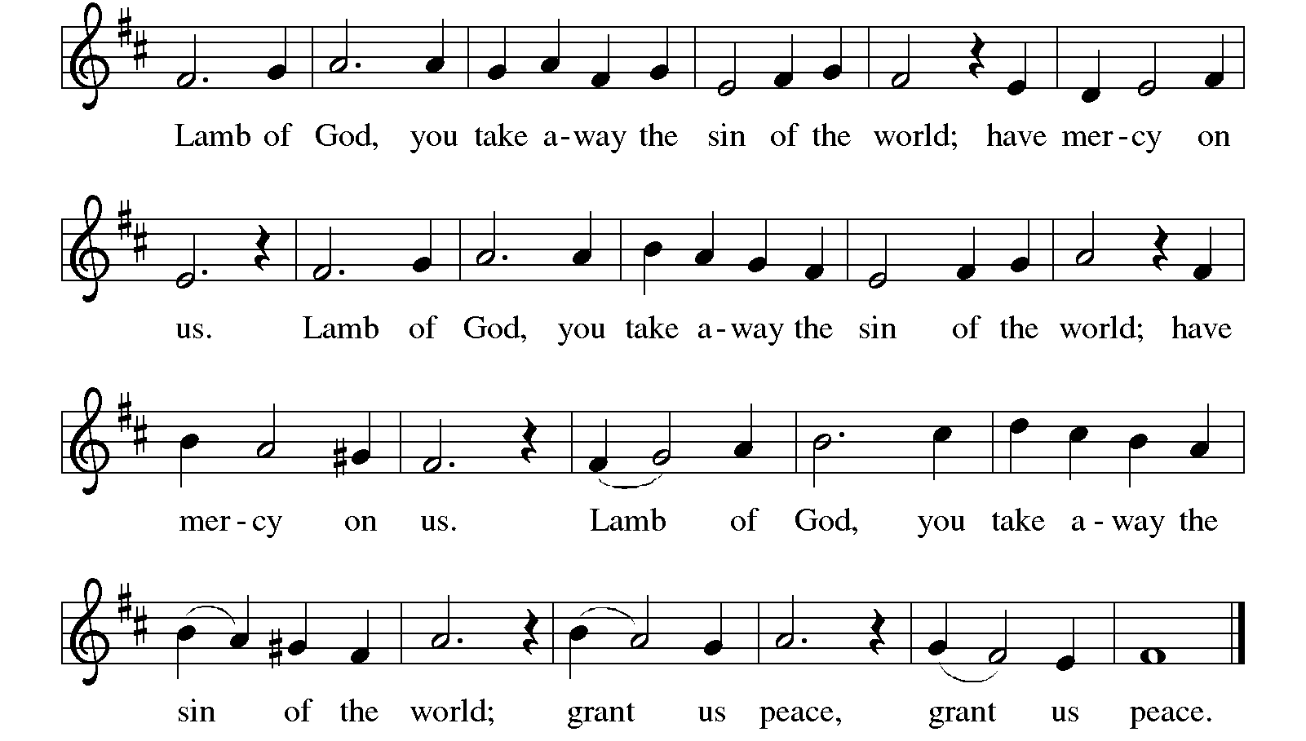
These are the gifts of God for the children of God. All who believe, all who want to believe, are welcome at the table of our Lord’s grace and mercy. Jesus is the host; we are the guests. Thanks be to God.

Come to the table, for all is prepared, and there is a place for you.

Those at home are invited to take their bread and wine or juice at this time.

Communion is distributed by intinction, dipping the bread into wine or juice.
If you prefer grape juice, cross your arms after receiving the bread and the assisting minister will pass by, and the acolyte will offer a chalice of grape juice. Please notify the server if you prefer a gluten free wafer.

May the body and blood of our Lord Jesus Christ strengthen and preserve you now and always. Amen.

Prayer after Communion

Let us pray: Shepherding God, you have prepared a table before us and nourished us with your love. Send us forth from this banquet to proclaim your goodness and share the abundant mercy of Jesus, our redeemer and friend. Amen.

Announcements A complete list of announcements can be found
at the end of the bulletin.

Blessing

The God of steadfastness and encouragement grant you to live in harmony with one another, in accordance with Christ Jesus. The God of hope fill you with all joy and peace in believing, so that you may abound in hope by the power of the Holy Spirit. The God of all grace ☩ bless you now and forever. Amen.

Sending Hymn: “He Leadeth Me”

Dismissal

Let us go in peace to love and serve the Lord. Thanks be to God! Alleluia!

Serving Today

Presiding Minister: Pastor Sue Irvin
Assisting Minister: Claudia Halliburton
Music Director/Accompanist: Beth Adee
Guitarists: Josh Moorman
Robert Ydstie
Sacristan: David Nelson
Acolyte: Terri Johnson
Communion Prep: Terri Johnson
Ushers: Mary Kemhus &
Julia Fanning
Offering Counters: Terri Johnson &
Tami Olson

Coming Up at Our Saviour’s

Tuesday at 10:30 am Ecumenical Bible Study, East Hall
Thursday at 9:30 am Quilters, East Hall
7:00 pm Book Group

Sunday, April 28 Fifth Sunday of Easter
9:00 am Bible Study
10:00 am Worship
11:00 am Fellowship, East Hall

Announcements

We will be welcoming new members into the congregation on Sunday, May 19. If you are interested in becoming a member, please see Pastor Sue.

The Adelman Peony Gardens is a fun, relaxing day trip near Brooks Oregon! The Peonies will be in full, fragrant bloom mid to late May! Anyone interested in meandering through their lovely display garden and/or amongst the rows in acres of peony varieties please let me know. I will be driving with the possibility of another driver as needed! We could plan on a weekday or Saturdays. Please call me or check in on Sundays prior to May 7th! Thank you, Mitzi

If you are interested in playing bells with the hand bell group, please contact the church Music Director, Beth Adee.

Collection list for the South County Food Bank: canned fruit, peanut butter, toothpaste, mayonnaise, mustard, ketchup, syrup, pancake mix. The collection barrel is by the mailboxes in the front entry.

Please send announcements and updates to the prayer request list to the church office, by phone or email, by noon on Wednesday, or fill out an announcement form (located in the Council Corner in the East Hall) and place in the basket on Pastor Sue’s door.

